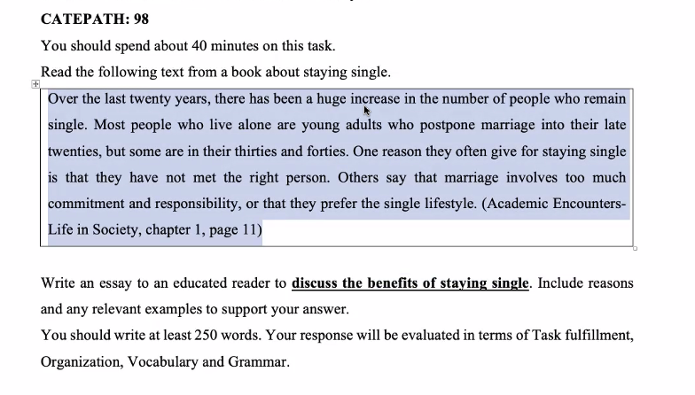

-Online learning

+Save time

+convenient

+Economical

+It cannot be denied that the number of people who learn online has **dramatically(đột ngột)** increased in the past few years. More and more people (Ngày càng nhiều người) are becoming interested in learning online. It is true that online learning bring us various benefits, and some of these will be discussed as follows.

The first benefit we can consider is that online learning is economical .

Another positive aspect(mặt tích cực ) of online learning to take into account(=consider) is that it is convenient

One more advantage of online learning worth mentioning(đáng nói) is that students can save a lot of time

In conclusion (bao gồm) , online learning offers significant

Advantages of Watching TV

-Relax

-Update news

-Enjoyable

-Useful/helpful

Ex: watching TV is fun. It help people relax and reduce stress after a hard-working day

Disadvantage of watching TV

Ex: Watching TV is really useful. It enables people to improve their knowledge

**Disadvantages:**

-Cause problem of eye

-Harmful to people’s health

-Become addicted(say me) to watching TV

-negative: tiêu cực

-address: giải quyết

-decades: thập kỉ

-foremost: quan trong nhat

-consequences: Hậu quả

-inclusion : bao gom

-imperative :mệnh lệnh / necessary

-governments

-businesses:

-Outlinghted

-potential solutions: tiềm năng giải quyết

-raise:

-deforestation:

Awareness: